

SINGAPORE EPSON IND PTE LTD
U8 ERP Implementation Solution Report

Version Date | : | 22 Dec 2015
Document Version | : | 2.1
Document Control No. | : | Epson_020203



Authors
This document was prepared by:
Jason Huang, Consultant
YONYOU (Singapore) Pte Ltd
Office Phone: (65) 6515 0800 / 6515 6502
Jasom.Huang@yonyou.com.sg

Version History
Date | Document Version | Document Revision History | Document Author / Reviser
26-11-2015 | 1.0 | Initial Draft | Jason Huang
09-12-2015 | 1.1 | Initial Draft | Jason Huang
10-12-2015 | 1.1 | Initial Draft | Jason Huang
15-12-2015 | 1.2 | Initial Draft | Jason Huang
18-12-2015 | 2.0 | Initial Draft | Jason Huang
22-12-2015 | 2.1 | Final Vision | Jason Huang

Approvals
Date | Document Version | Approver and Title | Approver Signature

Table of Content
1.0 Overview of Implementation Solution 1
2.0 Project Overview 2
2.1 Project Background 2
2.2 Project Objective 2
2.3 Implementation Modules 3
2.3.1 Project Boundary 4
2.3.2 Implementation Location 4
3.0 SEP Business Process Flows 5
3.1 Business Process 5
3.1.1 EPCOS Sales 5
3.1.2 Local Sales 6
3.1.3 One-Stop Sales 8
3.1.4 Watch Case / Watch Part / Glass Sales 10
3.1.5 Microelectronics (Flex Tape) Sales 11
3.1.6 Purchase Process 12
3.1.7 Material Outbound Process 13
3.1.8 Printing Barcode: 14
3.1.9 Splitting Barcode: 15
3.1.10 Adjustment Barcode: 16
3.2 Master Data 16
3.3 Inventory counting 17

Overview of Implementation Solution

During the requirement study phase, detailed study and analysis have been conducted around the business processes in the company both internally and externally, as well as identified their current process flows and requirements. Implementation solution is then designed specifically based on the analysis results. The implementation solution will act as a blueprint for the system built and user testing which will then be verified as a firmed solution after passing the test.

The implementation solution is designed based on the business needs and further enhanced by re-engineering the unnecessary processes. During the design process, the best practices and value-added processes in the company need to be retained and those redundant and cumbersome process must be removed. Meantime, the simulation of the solution will be carried out in the test environment with the following flows:
- Business process analysis and standardization – to analyze the business processes and formalize the unorganized processes and procedures.

- Gaps fit between business requirements and software functions – to verify the gaps between the requirements and software functions by describing the approaches in realizing the matched functions and proposing the actions to be taken on the unmatched function, for instance customization.

- Simulation of proposed solution – to conduct simulation on the test environment. Setup discussions among the implement consultants and project team to confirm if the solution well fits the business requirements. If any issues found, an immediate communication and action need to be taken.

- Solution endorsement – once the simulation test is passed, the solution will be endorsed by the project managers of both parties. The endorsed solution will become a firmed solution to be referred for production instance setup.

Basic rule of thumb for designing the implementation solution:
- Employ business flows diagram for easy understanding of the business processes.
- Streamline the processes and operations in the system by eliminating unnecessary steps.

Project Overview

  - Project Background

2.1.1 Company Introduction
This document is created by Yonyou project team based on the discussion with Singapore Epson Ind Pte Ltd (hereinafter referred to as “SEP”) for the current business operations as well as the future operations in supply chain.

The main purpose of the requirements study is to identify the business problems and user requirements in trading operations to establish the solutions in U8 ERP to support their business transactions. As such, this implementation aims to elicit views from the sales and purchasing department as to which areas of the sales and purchasing operations the U8 ERP should cover, including key areas for what method of pricing control that should be supported.

1.1.2 SEP Business Organization
Figure 1 Departments
  - Project Objective

2.2.1 Sales Management
- Sales process flow accordance to different type of sales.
- Manage and standardize Sales Order, Delivery Order and Sales Invoice process.
- Printing Delivery Order and different type Sales Invoice.
- Customer credit control, sales order will be blocked if over customer credit limit.
- Auto generate sales price from customer inventory price list (Update price list monthly by batch import).
- Set price as confidential data, limit access and control according to credential.
- Recorded in the sales process with the number of days (Sales create to delivery).

2.2.2 Purchase Management
- Build purchase management process flow.
- Automatically generate latest purchase price and able to review historical purchase price.
- Set price as confidential data, limit access and control according to credential.
- Expiry Date control for chemical material.
- Provide monthly Invoice Listing Report to Finance Department (By Reason Code and Invoice No).
- Review unbilled transaction details (No Invoicing after stock-in).
- Inventory transaction summary (Qty and Cost).
- Inventory cost by month average.

2.2.3 Inventory and Manufacturing Management
- Real time monitor and track inventory quantity.
- Summarize material usage according to Department and Inventory Classification.
- Monitor manufacturing transfer status during manufacture process.
- Fully barcode scan process during inventory inbound, outbound and transfer order.
- Inventory transaction summary (Qty, OS include cost).
- Recorded in the production process with the number of days (Production start to end).
- Statistics sales order to deliver a few days.
- Query status of production by barcode.
- Analysis value of inventory based on its age (Surplus 50% after six months. Surplus 10% after nine months).
- Inventory Counting by half-yearly.

2.2.4 Finance Management
- One-Stop sales purchase cost management.
- Purchase and Sales Invoice will be sent to SAP accordance to the standard format via integration interface.
- Payment and receivable receipt in SAP will transfer to ERP.
- AP and AR balance analysis chart.
- Periodically provide credit limit and payment term to Finance.

  - Implementation Modules
Figure 2 Project Modules
As illustrated in the above figure, the implementation modules in Yonyou U8 ERP are:
- Master Data Management
- Financial Management
  - Account Receivable
- Supply Chain Management
  - Purchase Management
  - Sales Management
  - Inventory Management
  - Inventory Accounting
- Customization
  - Barcode Management
  - Data Integration

    - Project Boundary
- This project will affect SEP operations only. All other locations are out of scope.

- Yonyou will deliver the solution based on production barcode management, data integration and the purchased modules to the related department only. All other departments are out of scope.

    - Implementation Location
- This project will be conducted in Singapore only.

SEP Business Process Flows

  - Business Process
SEP receipt customer order to manufacture. It includes sales order, receipt, production transfer, delivery and invoice businesses.
Business Type (Sales Type)：
No. | Code | Description
1 | ES | EPCOS Sales
2 | LS | Local Sales
3 | OS | One-Stop Sales
4 | WC | Watch Case Sales
5 | WP | Watch Part Sales
6 | PP | Glass Sales
7 | CS | Microelectronics (Flex Tape) Sales
8 | PM | Purchase Management

    - EPCOS Sales
Figure 3 EPCOS Sales Process
Explanation:
- Export fixed format file from in-house Web App (Remark: import format is CSV).
- Import the CSV file into Yonyou system to generate a data list. Automatic generate Sales Order after the data approved, Sales Order approval triggers product stock-in. Sales Order price comes from inventory price list. The price comes from item and customer.

Explanation of import rules:
Automatic match the sales type / warehouse from Configuration Table.

- Production process management in Web App. So referring to Sales Order to generate Sales Invoice after delivery.

- After invoice approved, Invoice will be exported by fixed time or manually. Export rules in accordance with <Invoice Export Rule>.

    - Local Sales

Figure 4 Local Sales Process
Explanation:
- According to customer requirement create SO by manual. Automatic generates stock-in after SO approved.

- If customer does not provide lot number, system will auto-generate lot number.

- Referring to SO to print Barcode and Lot Card.
Barcode information refers to Barcode Printing.
Lot Card information refers to Lot Card Printing.

- Scanning barcode for production outbound.

- Determine whether there is reject.
If there is a reject, need to split barcode, trigger Barcode Split Process.
Else transfer to next production process or finished good stock-in.

- Delivering by scanning barcode. Automatic generates Delivery Order, generates Sold Outbound after DO approved, and synchronous modify the SO status.
The rules of update SO:
- Delivery cannot exceed the number of sales orders.
- When an equal number of shipments and orders, Sales Orders automatically close.
- Delivery quantity is less than the number of orders, Sales Orders are still open.

- Refer to Delivery Order generates Sales Invoice. It will be exported to TXT file automatically.

    - One-Stop Sales
Figure 5 One-Stop Sales Process
Explanation:
- Create Sales Order according to customer requirements.

- Marketing refers to Sales Order to generate Purchase Order and send to vendor.

- When vendor delivery to warehouse receipt and print barcode.

- Scanning barcode for production outbound.

- Determine whether there is reject.
If there is defective product, need to split barcode, trigger Barcode Split Process.
Else transfer to next production process or finished good stock-in.

- Delivering by scanning barcode. Automatic generates Delivery Order, generates Sold Outbound after DO approved, and synchronous modify the SO status.
The rules of update SO:
- Delivery cannot exceed the number of sales orders.
- When an equal number of shipments and orders, Sales Orders automatically close.
- Delivery quantity is less than the number of orders, Sales Orders are still open.

- Refer to Delivery Order to generate Sales Invoice. It will be exported to TXT file automatically.

3.1.3.1 One-Stop Sales (Credit Note Process and Reject Process):
Figure 6 Credit Note and Reject Process
- Transfer to reject warehouse by scanning.
- Case when vendor don’t need to redelivery:
- PP&C refers to Purchase Order to generate Return Order, refer to Return Order to generate Red-Receipt.
- Delivery to vendor.

- Case when vendor need to redelivery:
- Create a stock-out document to deliver the reject product to vendor.
- Create a stock-in document to receipt redelivery from vendor.

    - Watch Case / Watch Part / Glass Sales
Figure 7 Watch Case / Watch Part / Glass Sales Process
Explanation:
- Import the CSV file obtained from EPJ and generates SO. Automatic generates stock-in after SO approved.
Remark: There is no inventory file when import time; need to determine inventory file exists, given the appropriate prompt.

- Referring to SO to print Barcode and Lot Card.
Barcode information refers to Barcode Printing.
Lot Card information refers to Lot Card Printing.
Remark: Customer provides Barcode in WP, so user need not print barcode.

- Need to confirm Qty before production outbound for WP sales. If the number of the sales order is not equal, need to trigger Adjust Barcode Process.

- Scanning barcode for production outbound.

- Determine whether there is defective product.
If there is defective product, need to split barcode, trigger Split Barcode Process.
Else transfer to next production process or finished good stock-in.

- Refer to Delivery Order to generate Sales Invoice. It will be exported to CSV file automatically for EPJ and TXT file for finance.

    - Microelectronics (Flex Tape) Sales
Figure 8 Microelectronics (Flex Tape) Sales Process
Explanation:
- Import the CSV file obtained from customer, and generates SO. Automatic generates stock-in after SO approved.

- Referring to SO to print Lot Card.
Lot Card information refers to Lot Card Printing.
Remark: Customer provides Barcode in CS, so user need not print barcode.

- Scanning barcode for production outbound.
- Determine whether there is defective product.
If there is defective product, need to split barcode, trigger Adjust Barcode Process.
Else transfer to next production process or finished good stock-in.
- Refer to Delivery Order to generate Sales Invoice. It will be exported to CSV file automatically for customer and TXT file for finance.
- Reject process:
- Transfer to reject warehouse by scanning barcode.
- Scanning to generate Delivery Order.
- Refer to DO to generate Sales Invoice, but need to modify amount to zero and show material cost.
- This Sales Invoice does not need to export to finance.

    - Purchase Process
Figure 9 Purchase Process
- Generate purchase order based on Purchase Requisition, and then send the Purchase Order to supplier.
- Supplier delivery material to warehouse, warehouse department receives material.
- Purchase department records the purchase invoice and confirms the purchasing cost.
- Expense invoice, no need for storage, purchase invoices directly filled.
- Submit purchase invoice to finance department.

Purchase Credit Note:
Figure 10 Purchase Credit Note Process
- Refer to Purchase Order to generate Return Order to confirm rejecting.
- Refer to Return Order to generate Red-Receipt after Return Order approved.
- If invoiced, then vendor need to create Credit Note.
    - Material Outbound Process
Figure 10 Material Outbound Process
- Production creates Material Outbound according to material requirement and submit.
- Director approves the Material Outbound when receipt the approve message.
- Warehouse manager approves finally to stock-out.

    - Printing Barcode:
Figure 11 Printing Barcode Process
- Query the approved Sales Order list.
- The query result default is Sales Orders that have not printed barcode. But user can select the Sales Orders that have printed barcode to print barcode again.
- The print barcode list as below:
Select | SO # | Item | QTY | Printed barcode | Lot No.
Y | SO1001 | BZ-00081 | 2800 | Y | R0000428
 |  | Barcode | QTY | Lot No. | …
 |  | B001 | 1000 | R0000428
 |  | B002 | 1000 | R0000428
 |  | B003 | 800 | R0000428
 | SO1002 | BZ-00091 | 1500 | N | R0000429

- Barcode information:
Item No | Item Name | Classification | CUST Order # | CUST Lot | PO # (OS) | CUST Code | Vendor Code | Qty | UOM | Due Date | Department of Production |

- Rule of Barcode:
Sales Type + Batch No. (LS1512030001)
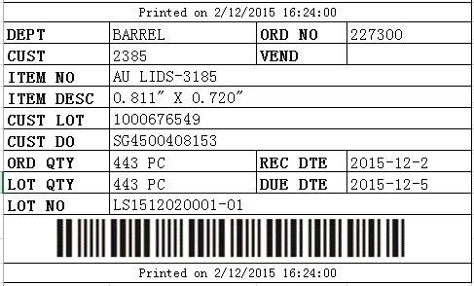

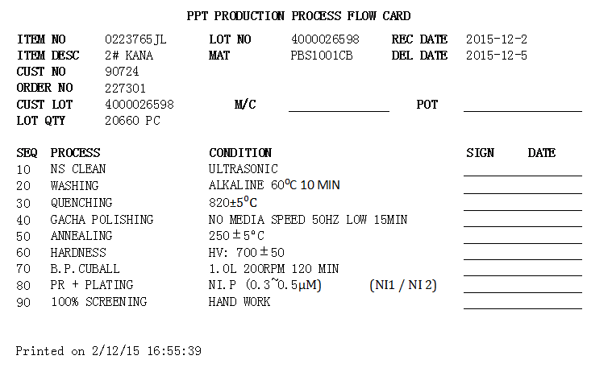
    - Splitting Barcode:
Figure 12 Splitting Barcode Process
- When there is reject, barcode needs to be split into two.
2. If need to cancel or modify the splitting, go to change quantity between the two barcodes that have the same lot number.
    - Adjustment Barcode:

Figure 13 Adjustment Barcode Process

- Adjustment means to modify the quantity of the barcode.
- When adjustment, system will automatic trigger two process:
- Update the quantity of Sales Order to right charge.
- Generate stock-out document to equal stock.

  - Master Data
- Warehouse file
- Sales Type
- Customer and Vendor file
- Inventory classification and inventory file
- Routing
- Price List
- Customer inventory price list
- Routing case type price list

  - Inventory counting
Figure 8 EPSON Business Flow Diagram – Inventory Counting
- Print blank counting list based on Stock Take Sheet.
- Warehouse department staff to fill the quantity on Stock Take Sheet after stock take.
- Stock Take Sheet must be approved by supervisor or store manager.
- System will auto generate Misc. Inbound and Misc. outbound based on the gain or loss.

Endorsement and Approval
The undersigned acknowledge that they have reviewed the Implementation Solution Report of Singapore Epson Ind Pte Ltd U8 ERP Project and agree with the information presented within this document. Changes to this Implementation Solution Report will be coordinated with, and approved by, the undersigned, or their designated representatives.

Signature | : |  |  | Date | :
Name | :
Role | : | Project Manager of EPSON

Signature | : |  |  | Date | :
Name | :
Role | : | Project Manager of YONYOU

